**Testing**

Clear evidence, in the form of carefully selected representative samples, that thorough testing has been carried out. This demonstrates the robustness of the complete or nearly complete solution/thoroughness of investigation and that the requirements of the solution/investigation have been achieved.

This document is divided into sections containing the testing of each source file. Many of the source files are unit tested.

**MMLtoMIDI makefile**

The contents of the makefile at the time of the following two tests are shown below.

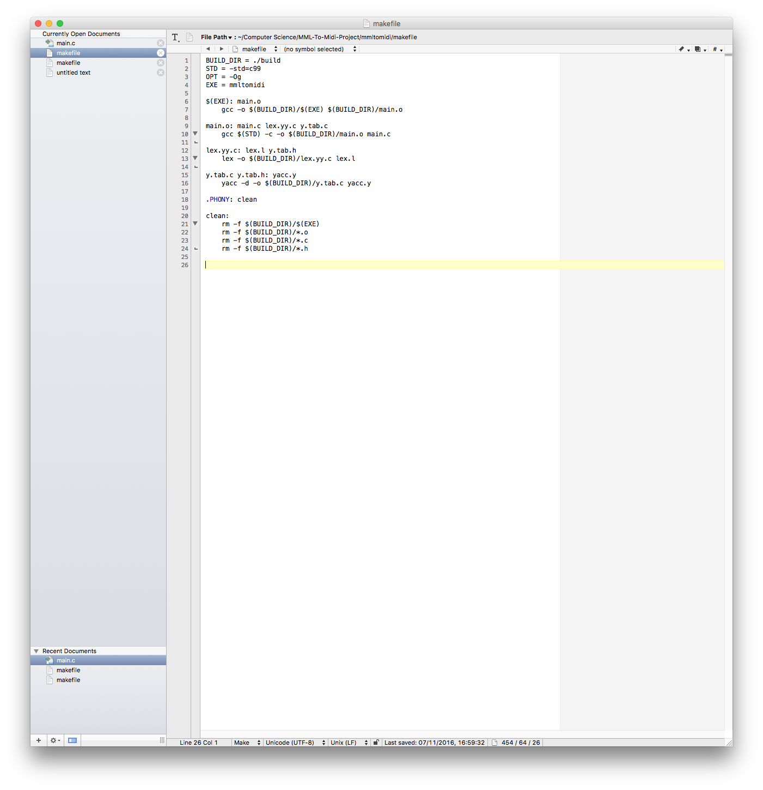

A test using “make” without any arguments is below.

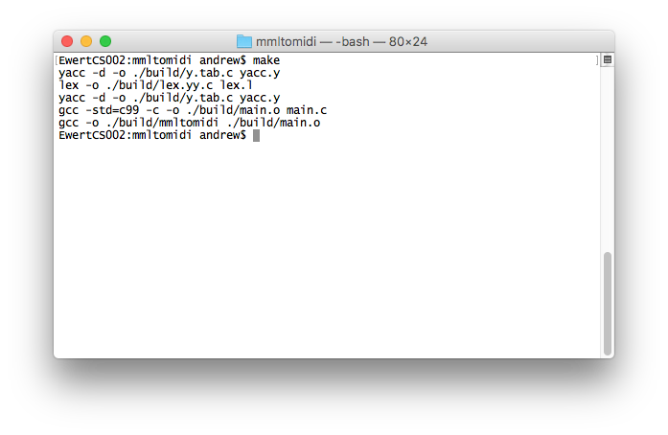

A test of the makefile using “make clean” is below.

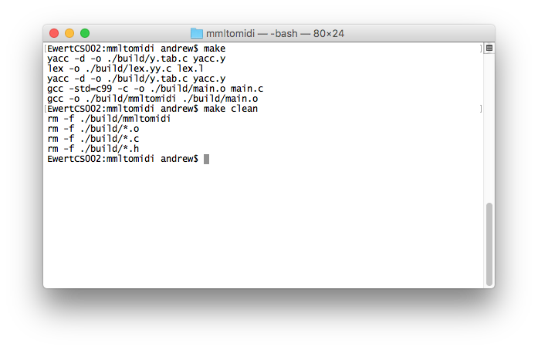

Both of these tests show that the makefile is being executed by make as intended. This makefile will not be updated over the course of this project, so this is the final test that needs to be performed.

**main.c**

callValid

**lex.l**

**yacc.y**